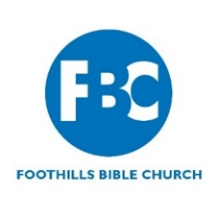
Job Posting

Formation Administrator

Company Information
Foothills Bible Church (FBC) exists to help people become faithful followers of Jesus Christ. Our identity is that Everybody is Welcome, Because Nobody is Perfect, and God has Big Plans for Your Life. Our core values are:
- Gospel-Centered
- Journey-Minded
- Relationally-Driven
- Action-Oriented
- Welcoming-Focus
Located on a spacious campus nestled next to the foothills in Littleton, Colorado, FBC is a non-denominational church serving the Denver area since 1973.

Job Description
FBC is seeking a dependable and mission-minded Formation Administrator to provide vital administrative support for our Formation Pastor. This full-time role is key to helping FBC execute its vision of guiding people to become more faithful followers of Jesus.
The Formation Administrator will manage ministry systems, event logistics, communications, and volunteer coordination. The ideal candidate is a proactive problem solver with strong administrative skills, relational, and demonstrates a heart for ministry.
Responsibilities

Provide administrative support for all phases of the Growth Group cycle, including training and communication with leaders
- Support planning and execution of events like Formation classes, trainings, and Growth Group Leader kickoff/celebrations

Maintain accurate ministry data, including registrations, attendance, and congregant records

Manage calendars, appointments, and schedules for the Formation Pastor and related staff

Support pastoral care and counseling processes through scheduling and coordination
- Prepare content for the church website and printed ministry materials
- Assist in recruiting, training, scheduling, and coordinating volunteers
- Support Growth Group leaders with resources, scheduling, and ongoing communication
- Assist with planning and executing Growth Group ministry events and formation classes
- Coordinate logistics including room reservations, childcare, safety support, and outside vendors
- Order and maintain supplies, curriculum, and other materials
- Prepare materials for groups and events; manage shipping and mailing needs

Knowledge, Skills, & Abilities

Strong organizational and time management skills

Detail-oriented and able to work independently

Excellent interpersonal and communication skills

Comfortable using Microsoft Office, Google Workspace, and church database tools

Able to manage recurring responsibilities and meet deadlines with limited supervision

Requirements
- High school diploma
- 2 years of experience in off administration, church ministry, or volunteer coordination preferred
- If not already a member of FBC, should pursue membership during the introductory period
- Regular attendance at an FBC weekend service and participation in a Growth Group expected

Salary & Benefits
- Full-Time (32 hr/wk) Monday through Thursday
- Salary range: $19-21/hour
- Preschool Discount
- Occasional evening or weekend hours may be required for events or training sessions

Ready to Join Our Team?
- Please email your resume and cover letter to Nick Jones at njones@4fbc.org
- Deadline to apply: July 15, 2025

