#10 – The Power of Words, Part 1

6:30 – 8:00 p.m.
goING DEEPER and Taking it home
1. Looking back at your sermon notes, was there anything that particularly caught your attention, was new, challenging or confusing to you?
Use this question to get people thinking about the sermon again.

2. We all, in various ways and places, teach or influence people in their relationship with the Lord. What are some of yours?
As a parent, employee, boss, Sunday School Teacher, neighbor, etc.

3. Describe a time when your words were powerful.
Hopefully this and the next question help people recognize and acknowledge the power of what they say and how they say it.

4. Describe a time when someone's words had a powerful effect on you.

5. What have you experienced during the Tongue Assignment?
Encourage people to share their success and failures. Hopefully there will be humorous stories that everyone can relate to!

6. On a scale from 1-10, how would you rate yourself in controlling your tongue? What have you tried to do to control your tongue?
Encourage people to share and remind everyone that nobody is perfect, but God wants to work in our hearts and minds.

7. In the sermon we heard that "Changed words are a result of a changed heart." How does a person change their heart? Consider passages like Proverbs 27:17, John 15:5, Colossians 3:5-11, Hebrews 10:24-25.
By things like repentance, abiding in Jesus, spending time in the Word, taking steps of faith, having accountability relationships.
• Denver, CO – Westside Church International Summer Outreach Event, August 2
• Denver, CO – Open Door Ministry Outreach Event, TBD
• Cheyenne, WY– FE Warren AFB Day Trip, Wing Lunch, May 1
• Cheyenne, WY– FE Warren AFB Day Trip, Higher Grounds, Summer Wednesday nights
• Chinle, AZ – Navajo VBS and Annual Basketball Tournament, June 15-21
• Sierra Leone – Early Childhood Education Training, July
• China – Healthy Lives Nosu Students Summer Camp, July
• Ecuador – Children and Youth Ministry, August
• France – Operation Transit Outreach, June 22 – July 6
• Poland – Student English Camp, July 15-30
• Tanzania – ITEC Team, March
• Lebanon – Syrian Refuge Camp, Fall
• Care Direct Trips meeting with GO Workers, Dates Vary

“Collide” is an epic event for middle and high school students Friday, January 25 – Sunday, January 27! Sign up online.
Tongue Assignment Try to keep these “Laws” for one week:
James 3:1-5
Shawn Peterson
January 13, 2019

Review
How does Christian maturity happen?
1 - As you endure suffering and ask for wisdom
2 - As we hear and do the Word of God

How does Christian maturity change your relationships?
1 - With yourself
2 - With people who give you nothing
3 - With the world

1 – Christian teachers should _______________________________________

2 – Christian teachers will ___________________

3 – Words are ___________________

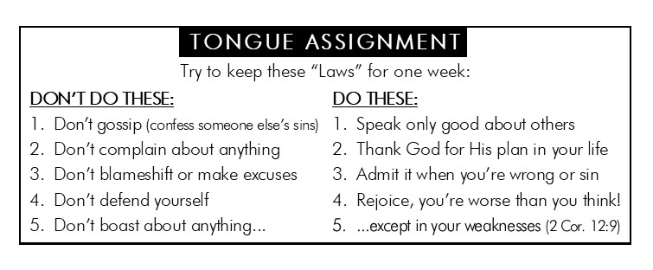
Growth Group Preparation Questions
For the week of January 13, 2019

Welcome to the Winter Growth Group Session!

This week kicks off the Winter Growth Group session at Foothills Bible Church. We are excited that you are in a G2 and are praying that you have a great time with your group as you grow in your relationship with God and with others.

If you didn’t get a chance to join a Growth Group yet, go online or give the church a call this week and we’ll help you get plugged in.

Use the following to get to know those in your group, to get ready for your group’s discussion, and to dig deeper into and apply some of the topics of the sermon.

Getting to know You
Spend some time getting to know each other. Even if your group was together last year, take this time to catch up.

- What did you do over the Christmas break?

- What was your favorite gift to give or receive this Christmas?

- If time and money (and your comfort zone) were not obstacles, which one of the GO Trips listed on the back would you participate in? Circle it and write down what appeals to you about that particular GO Trip.

goING DEEPER and Taking it home
- Looking back at your sermon notes, was there anything that particularly caught your attention, was new, challenging or confusing to you?

- We all, in various ways, teach or influence people in their relationship with the Lord. What are some of the roles you have, or have had, that influence(d) others?

- Describe a time when your words were powerful.

- Describe a time when someone's words had a powerful effect on you.

- What have you experienced during the Tongue Assignment?

- On a scale from 1-10, how would you rate yourself in controlling your tongue? What have you tried to do to control your tongue?

- In the sermon we heard that, "Changed words are a result of a changed heart." How does a person change their heart? Consider passages like Proverbs 27:17, John 15:5, Colossians 3:5-11, Hebrews 10:24-25.

GO Trip Opportunities for 2019

• Denver, CO – Westside Church Internacional Easter Outreach Event, April 19 and April 20
• Cheyenne, WY – FE Warren Air Force Base Day Trip – Wing Lunch, May 1
• Cheyenne, WY – FE Warren Air Force Base Day Trip – Higher Grounds, TBD
• Chinle, AZ – Navajo Vacation Bible School and Annual Basketball Tournament, June 15-21
• Denver, CO – Open Door Ministry Outreach Event, Summer TBD
• France – Operation Transit Outreach, June 22-July 6
• Sierra Leone – Early Childhood Education Training, July
• China – HL Summer Camp, July
• Poland – Student English Camp, July 15-30
• Ecuador – Children and Youth Ministry, August
• Denver, CO – Westside Church Internacional Summer Outreach Event, August 2
• Lebanon – Syrian Refuge Camp, Fall
For more information visit www.FoothillsBibleChurch.org/serve-far

Growth Group Prayer Requests:

